**WOMEN FASHION**

**w1 dress**

Maroon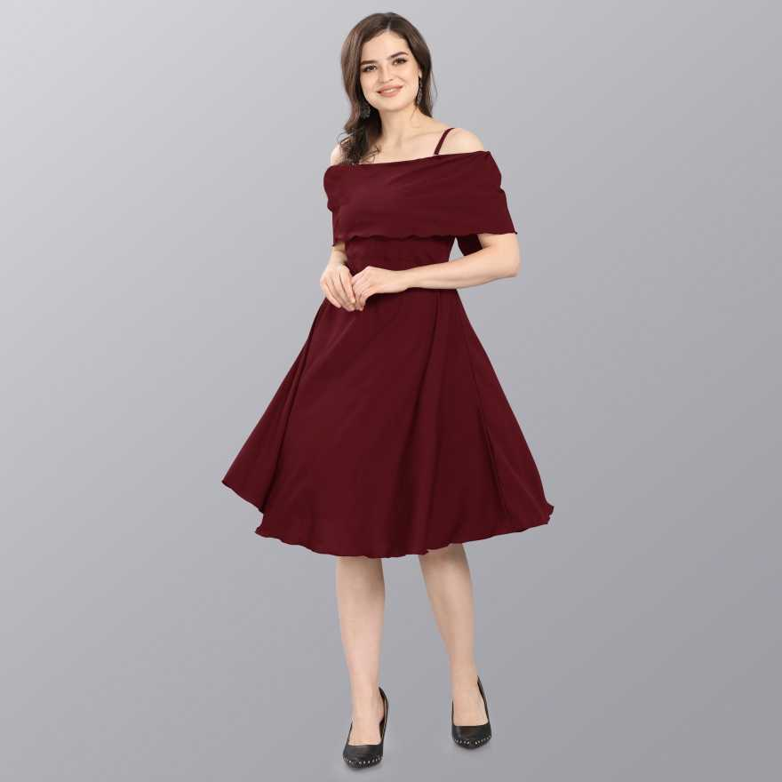

Length

Knee Length

Fabric

Crepe

Ideal For

Women

Type

A-line

Style Code

288

Suitable For

Western Wear

Sleeve Length

3/4 Sleeve

Orange

Length

Knee Length

Fabric

Polyester Blend

Pattern

Printed

Ideal For

Women

Type

A-line

Style Code

One Piece Orrange Line

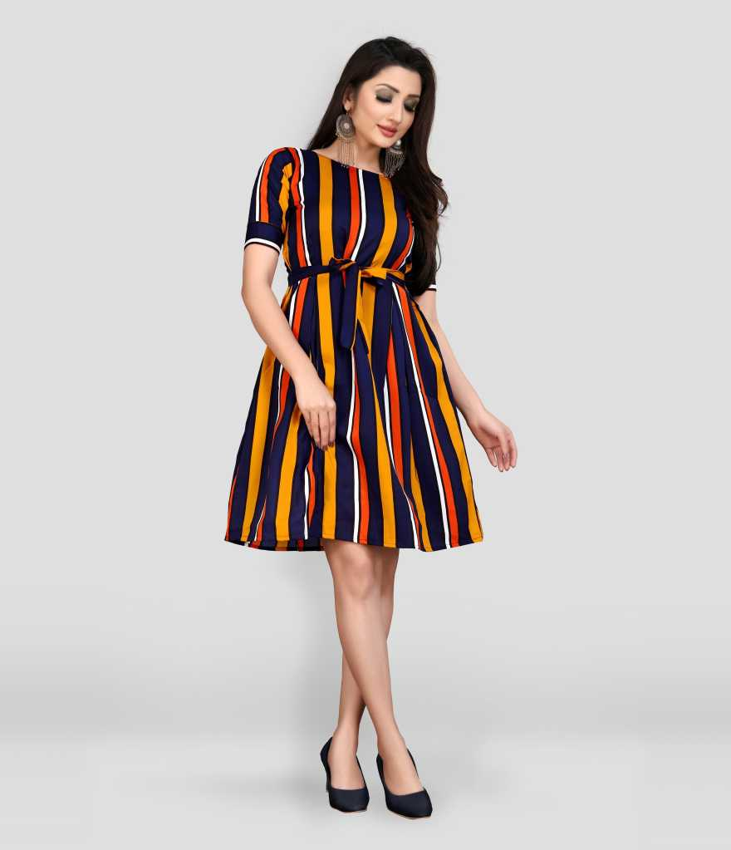 **l-one-piece-orrange-line**

**Micozy Women Skater Pink Dress**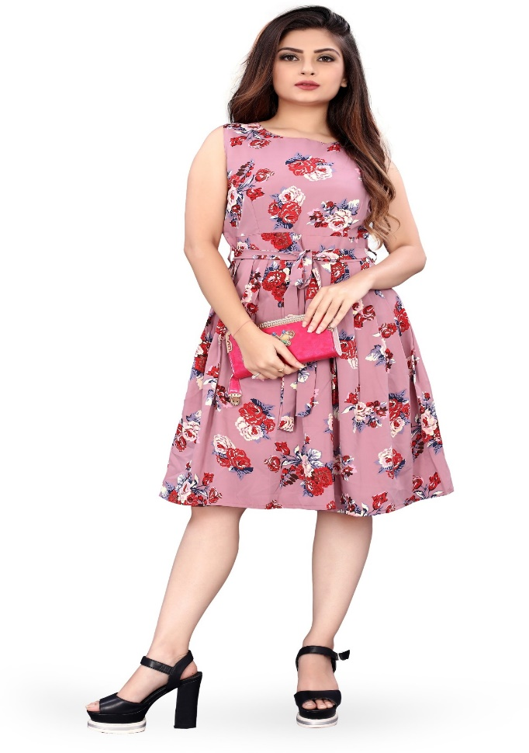

Pink

Length

Knee Length

Fabric

Crepe

Pattern

Printed

Ideal For

Women

Type

Skater

**xxl-g023-pink-jhankhi**

Pink

Length

Midi/Calf Length

Fabric

Cotton Blend

Pattern

Solid

Ideal For

Women

Type

Bodycon

**JWELLERY**

**Pearl Zaveri**

Zinc

Plating

Gold-plated

Color

Green, Brown

Model Number

ZPFK7345

Model Name

TRADITIONAL

Ideal For

Women, Girls

Type

Chandbali Earring

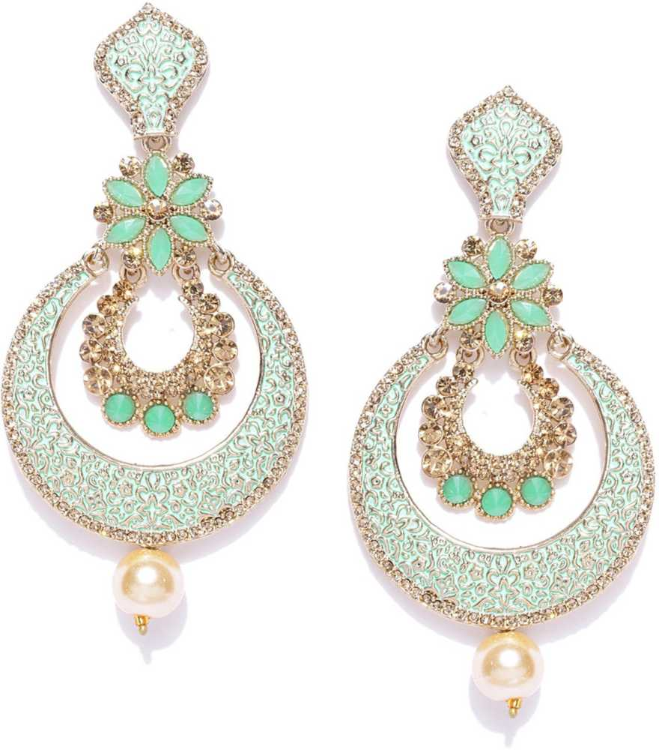

**Alloy Bangle Set  (Pack of 2)**

Women, Girls

Type

Bangle Set

Color

Gold

Base Material

Alloy

Bangle Size

2-4

Pack of

2

**Alloy Jewel Set  (Gold)** 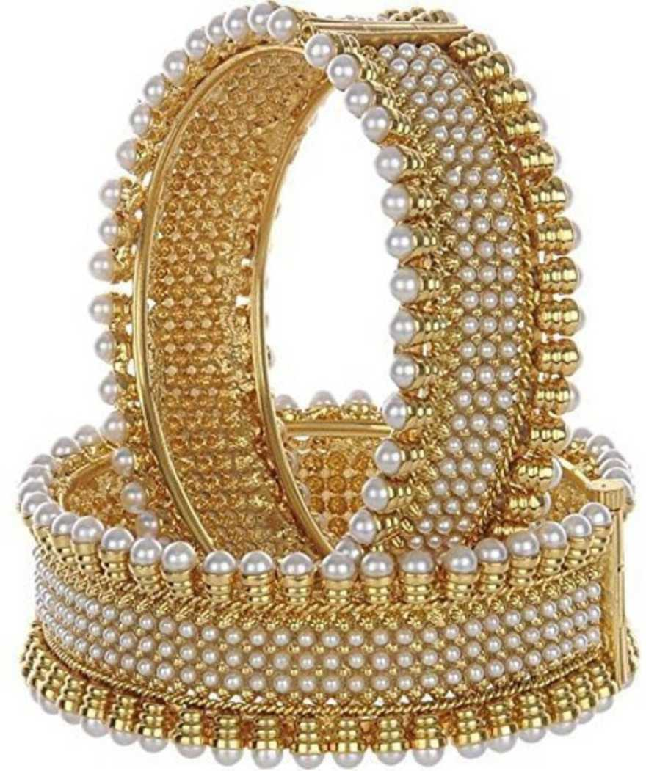

Alloy

Color

Gold

Type

Necklace, Earring & Maang Tikka Set

Ideal For

Women, Girls

Plating

Gold-plated

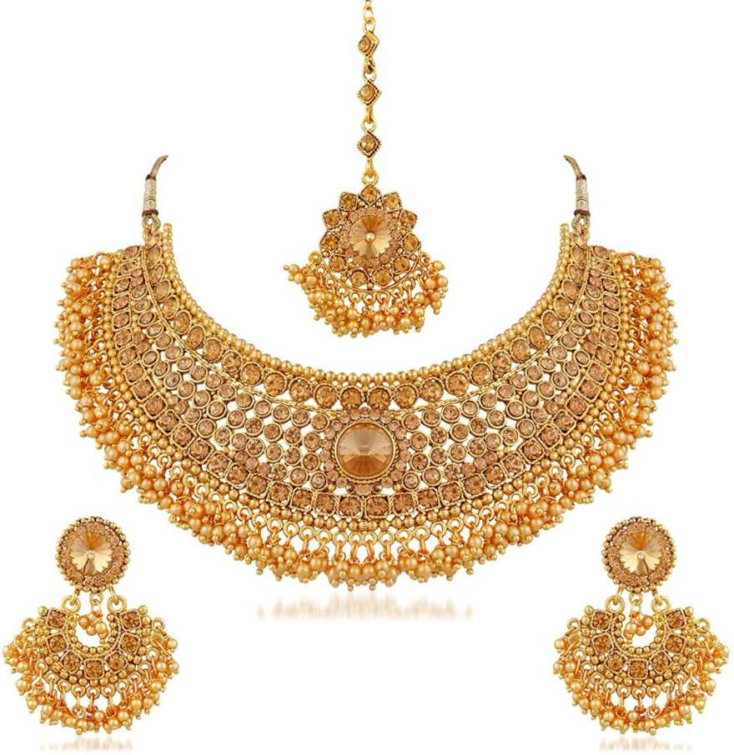

**Crystal Cubic Zirconia Gold-plated Bracelet**

Type

Bracelet

Color

Gold

Base Material

Crystal

Bangle Size

Free

Gemstone

Cubic Zirconia

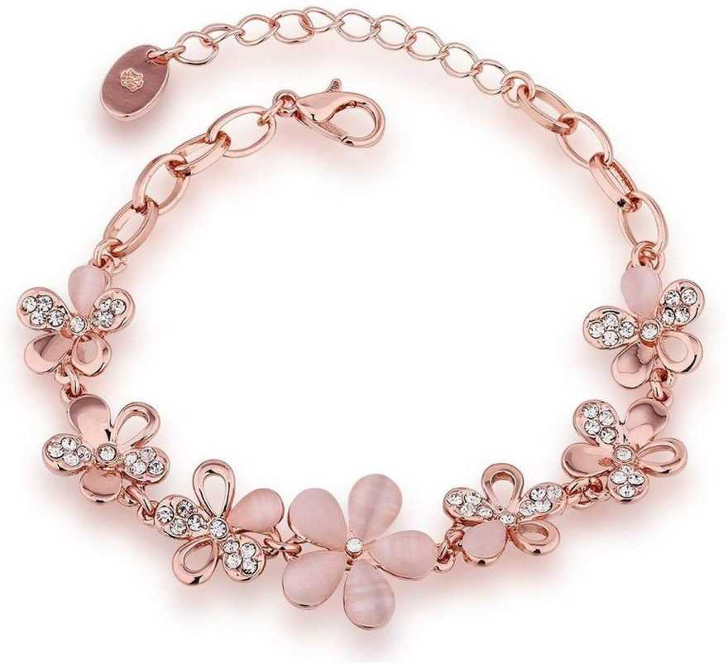

**Accessories**

Women Pink Hand-held Bag

Bag Size

Medium

Material

Synthetic Fabric

Width

14 inch

Height

14 inch

Closure

Zip

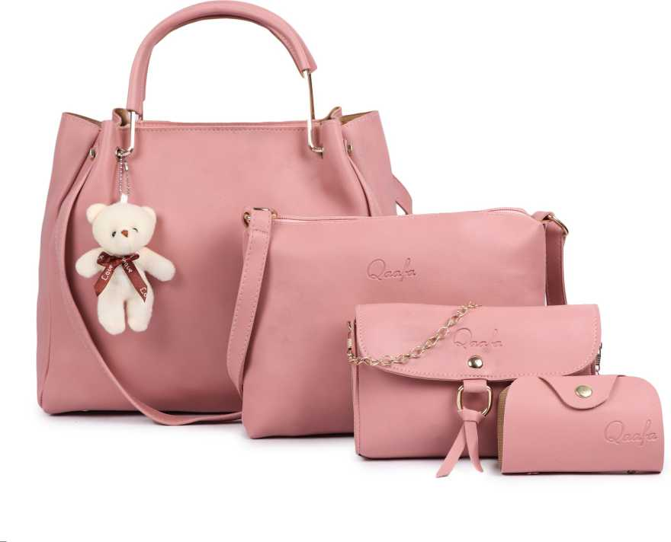

**Party Gold Clutch**

0

Closure

Clasp

Material

Synthetic Leather, Fabric Flowers, Metal

Number of Compartments

1

Width

6.3 inch

Height

6.5 inch

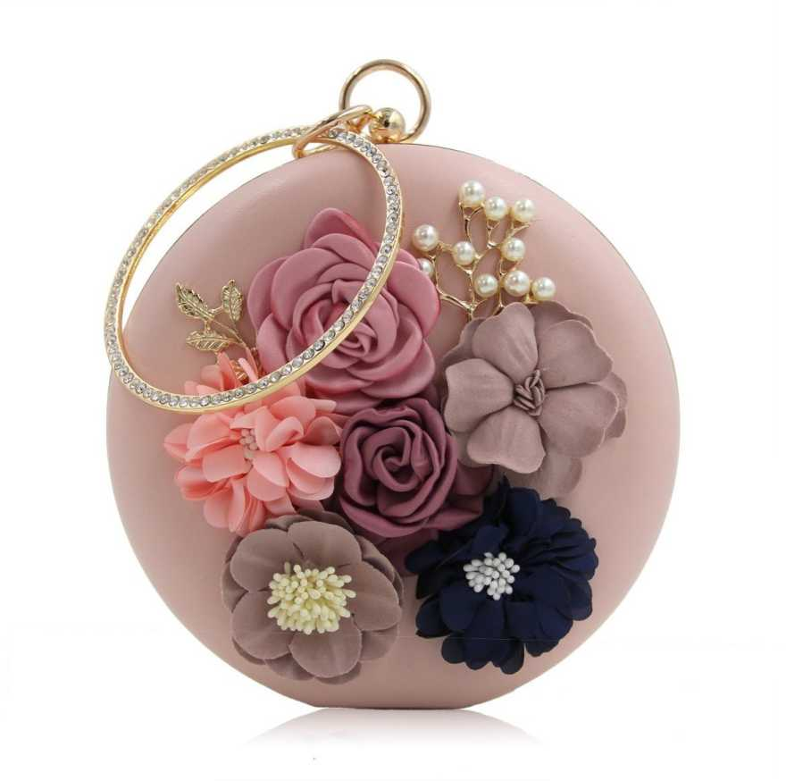

**Gradient, UV Protection Wayfarer Sunglasses (52)  (Brown, Pink)**

ens Color and Material

Brown, Pink, Plastic

Features

Gradient, UV Protection

Frame Color

Transparent

Type

Wayfarer

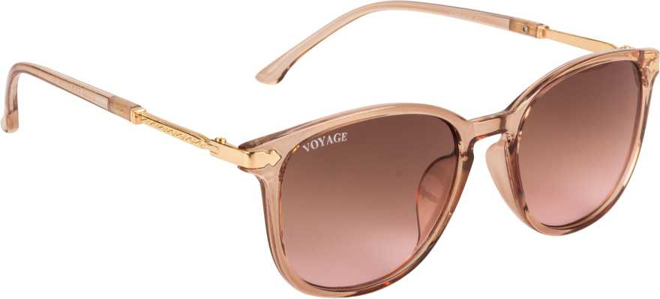

**Zod Runner V3 Wn s IDP Running Shoes For Women  (Pink)**

Color

Pink

Outer Material

Mesh

Model Name

Zod Runner V3 Wn s IDP

Ideal For

Women

Occasion

Sports

Sole Material

Rubber

Closure

Lace-Ups

